# Part 2: Modify the Pig Dice game to use objects

Part 2 of this case study has you modify the Pig Dice game from part 1 so that it uses objects to implement the game.

If you haven’t completed part 1 yet, you’ll need to do that first, unless it’s given to you as a starting point.

Prerequisites: Chapters 1 to 12

## User interface

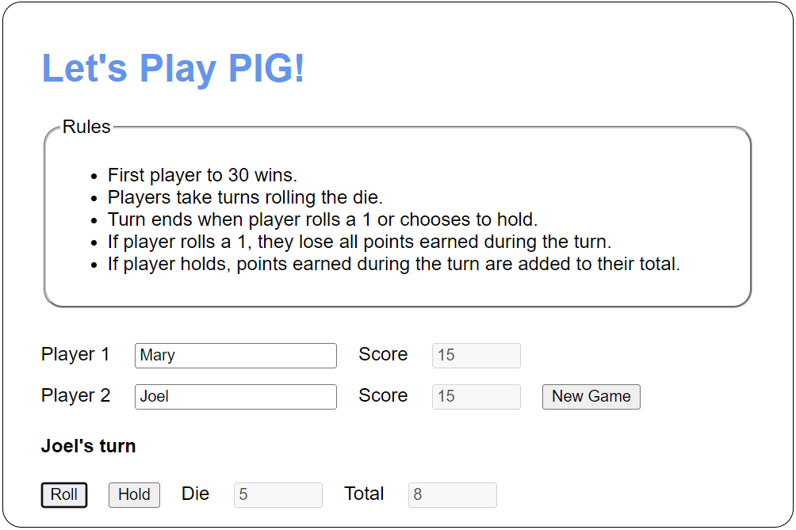

## Specifications

* Use a class to represent the die. It should include a roll() method that returns a random number between 1 and 6.
* Use a class to manage each player. It should include members for the username, total score, turn score, and roll value. It should also include methods for taking a turn, holding, resetting, and indicating if the user has busted or not.
* Use an object literal to represent the game. It should include a die object, two player objects and a property to track the current player. It should also include methods for starting the game, resetting the game, taking a turn, changing the player, updating the scores, and checking for a winner.